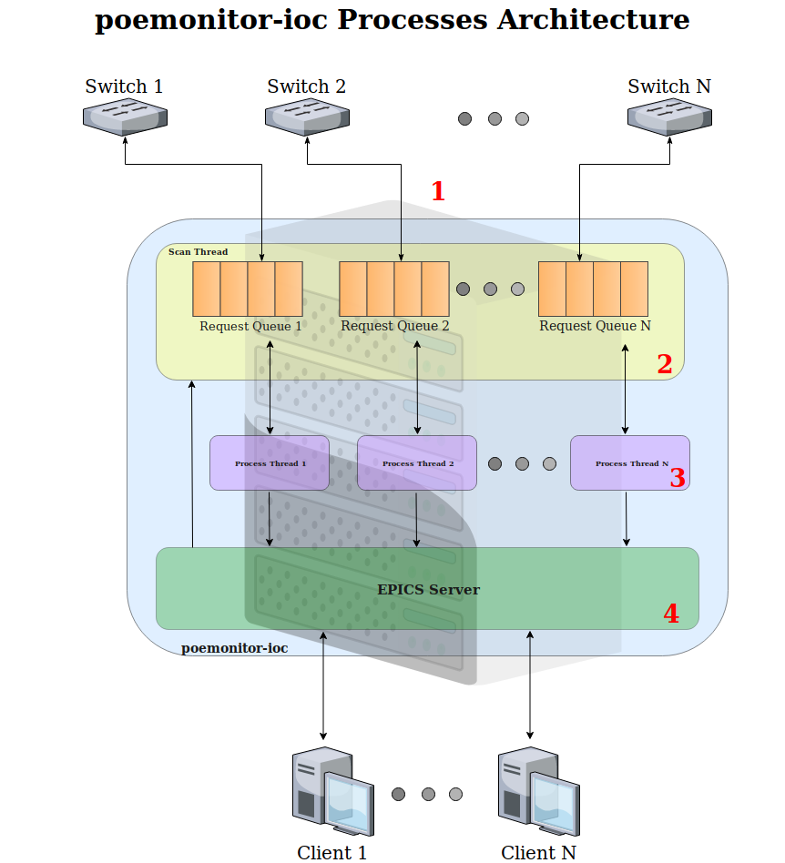

- EPICS Driver Module
  - Creates one request queue for each switch configured to be monitored on poemonitor.config file
  - Starts scan thread and one process thread for each request queue created before

- SCAN THREAD

  - Insert request for selector PVs value initialization (only on IOC boot)
  - Periodically inserts scan requests on each request queue

- PROCESS THREAD
  - Get requests from the respective request queue and process it
  - Implements connection failure resilience methods
  - Depending on IOC version, it is responsible for login authentication on REST API

- EPICS Server
  - Creates the interface for processing clients requests and, using EPICS driver module functions, inserts write requests on request queues

